1.資料怎麼產生？
def load_points_from_file(path: str):
result = []
with open(path, "r", encoding="utf-8") as f:
lines = f.readlines()
# 假設第一行是 header: id A1 A2 A3
for line in lines[1:]:
parts = line.strip().split()
if len(parts) != 4:
continue
pid = parts[0]
x, y, z = map(float, parts[1:])
result.append((pid, (x, y, z)))
return result

load_points_from_file會把每一行轉成 (id, (x, y, z))，存成 points_with_id，後面的演算法都用這個list。

2.怎麼用 R-tree 產生（建構 3D R-tree）？

MBR + 節點:
class MBR3D:
def __init__(self, low, high):
self.low = list(low) # [min_x, min_y, min_z]
self.high = list(high) # [max_x, max_y, max_z]

@staticmethod
def from_point(p: Point3D):
return MBR3D(p, p)

def expand_to_include(self, other: "MBR3D"):
for i in range(3):
self.low[i] = min(self.low[i], other.low[i])
self.high[i] = max(self.high[i], other.high[i])

class RTreeNode:
def __init__(self, is_leaf: bool):
self.is_leaf = is_leaf
self.children = [] # 葉: [(id, Point3D)]；內部: [RTreeNode]
self.mbr: MBR3D | None = None

def recompute_mbr(self):
mbr = None
if self.is_leaf:
for _, p in self.children:
pmbr = MBR3D.from_point(p)
...
else:
for child in self.children:
...
self.mbr = mbr

MBR3D 負責維護「這個節點涵蓋的最小長方體」，用 expand_to_include 一路往外擴

RTreeNode.recompute_mbr 會看所有子點或子節點，重新算出自己的 MBR

建樹（簡化版 bulk-load）:
def bulk_load_rtree(points_with_id, max_children=3) -> RTreeNode:
# 1. 先依 A1 排序
points_sorted = sorted(points_with_id, key=lambda x: x[1][0])

# 2. 每 max_children 個點塞成一個葉節點
leaves = []
for i in range(0, len(points_sorted), max_children):
node = RTreeNode(is_leaf=True)
node.children = points_sorted[i:i + max_children]
node.recompute_mbr()
leaves.append(node)

# 3. 自底向上 group 成內部節點，直到只剩一個 root
level = leaves
while len(level) > 1:
next_level = []
for i in range(0, len(level), max_children):
node = RTreeNode(is_leaf=False)
node.children = level[i:i + max_children]
node.recompute_mbr()
next_level.append(node)
level = next_level
return level[0] # root

先把點排序，三個一組裝成葉節點
再把葉節點三個一組裝成上一層內部節點，如此反覆，最後得到 root
每次裝完一個節點就呼叫 recompute_mbr 算出對應的包覆框

3.怎麼走訪 R-tree 產生 skyline（BBS 演算法）？

關鍵：判斷 MBR/點是否被 skyline 支配:
def dominated_by_skyline(p: Point3D, skyline_points: List[Point3D]) -> bool:
for s in skyline_points:
if dominates(s, p):
return True
return False

def mbr_corner_dominated(mbr: MBR3D, skyline_points: List[Point3D]) -> bool:
corner = tuple(mbr.low) # 左下角 (min_x, min_y, min_z)
return dominated_by_skyline(corner, skyline_points)

mbr_corner_dominated：如果 MBR 左下角被某個 skyline 點支配，整個 MBR 裡的點都不可能是 skyline，可以整塊剪掉

BBS 主迴圈：用 heap 走訪並產生 skyline

def skyline_with_rtree(root: RTreeNode):
skyline_ids = []
skyline_points = [] # 只存座標，用來判斷支配

# heap 裡放：(mindist, kind, obj)
# kind: 0 = node, 1 = point
heap = []
heapq.heappush(heap, (root.mbr.mindist_to_origin(), 0, root))

while heap:
dist, kind, obj = heapq.heappop(heap)

if kind == 0: # 處理「節點」
node: RTreeNode = obj
if skyline_points and mbr_corner_dominated(node.mbr, skyline_points):
continue # 整個 MBR 被支配，直接剪枝
if node.is_leaf:
# 葉節點：把裡面的「點」丟進 heap
for pid, p in node.children:
if not dominated_by_skyline(p, skyline_points):
md = math.sqrt(sum(c * c for c in p))
heapq.heappush(heap, (md, 1, (pid, p)))
else:
# 內部節點：把子節點丟進 heap
for child in node.children:
md = child.mbr.mindist_to_origin()
heapq.heappush(heap, (md, 0, child))

else: # kind == 1，處理「點」
pid, p = obj
if not dominated_by_skyline(p, skyline_points):
skyline_ids.append((pid, p))
skyline_points.append(p)

return skyline_ids

heap 初始化：先把 root 丟進去，優先權是 root.mbr.mindist_to_origin()。越靠近原點的 MBR 會越早被處理。

處理節點時：
先看有沒有 skyline 點支配它的左下角（mbr_corner_dominated），有就整個跳過（剪枝）。
若是葉節點，就把裡面的「點」算各自的距離、塞進 heap。
若是內部節點，就把子節點的 mindist 算好，塞進 heap。

處理點時：
看它是否被目前已知的 skyline 點支配，沒被支配就加進 skyline_ids 與 skyline_points。

4.怎麼走訪SFS產生skyline:
def sfs_skyline_with_id(points_with_id):
# 1. 給每個點計算加總分數（如 x + y + z），準備排序
scored = []
for pid, (x, y, z) in points_with_id:
score = x + y + z
scored.append((score, pid, (x, y, z)))
scored.sort(key=lambda t: t[0]) # 2. 將點按照加總分排序，分數越小越有機會進 Skyline

skyline: List[Tuple[str, Point3D]] = []
for _, pid, p in scored: # 3. 按順序一個一個檢查每個點
dominated = False
to_remove = []
for idx, (sid, sp) in enumerate(skyline):
if dominates(sp, p): # 4-1. 若已在 skyline 的某個點支配新點，就略過新點
dominated = True
break
if dominates(p, sp): # 4-2. 反之，新點支配舊的 Skyline 點，標記待移除
to_remove.append(idx)
if not dominated:
if to_remove:
skyline = [item for i, item in enumerate(skyline) if i not in to_remove] # 5. 移除被新點支配的舊 Skyline 點
skyline.append((pid, p)) # 6. 新點自身進 Skyline
return skyline

排序 → 給每個點計分，從小到大排。
走訪 → 一個個輪流檢查。
過濾 → 新點如果沒被目前 Skyline 支配，就納入 Skyline。反之則丟掉。
移除舊點 → 若新點比現有 Skyline 某些點還強，把它們移出來。

執行結果:
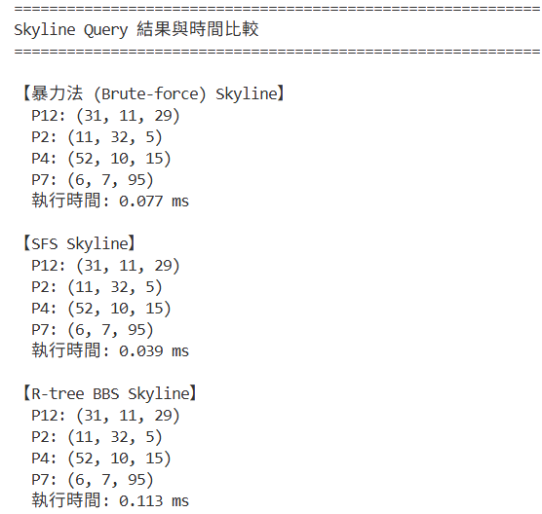
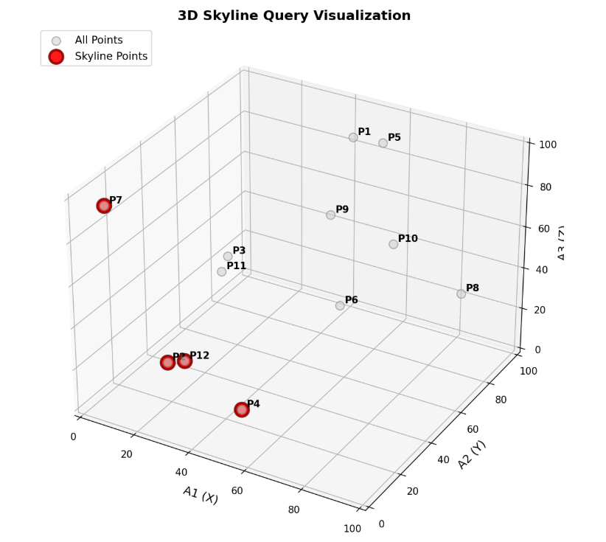

在我們執行一萬筆資料的時候，有出現一個問題
執行結果會顯示: TypeError: '<' not supported between instances of 'RTreeNode' and 'RTreeNode'

因為把(mindist, kind, obj) 這個 tuple 丟進 heap，如果前兩格「數值完全一樣」時，heapq會去比較第三項（obj 物件本身），而你的 RTreeNode 不能互相比較（沒有 < 定義），所以會報錯。

那我們就是加一個「唯一的數字 tiebreaker」，讓這個 tuple「前三項」就保證可以比較，不會比到 obj 物件本身。

在開頭的部分加:
import itertools
counter = itertools.count()

然後下面每次 heappush，都要補進 next(counter) 這一欄

# heap 裡放：(mindist, kind, tiebreaker, obj)
heap = []
heapq.heappush(heap, (root.mbr.mindist_to_origin(), 0, next(counter), root))

while heap:
dist, kind, _, obj = heapq.heappop(heap)

if kind == 0:
# ...（原本不變）
if node.is_leaf:
for pid, p in node.children:
if not dominated_by_skyline(p, skyline_points):
md = math.sqrt(sum(c * c for c in p))
heapq.heappush(heap, (md, 1, next(counter), (pid, p)))
else:
for child in node.children:
md = child.mbr.mindist_to_origin()
heapq.heappush(heap, (md, 0, next(counter), child))
else:
pid, p = obj
if not dominated_by_skyline(p, skyline_points):
skyline_ids.append((pid, p))
skyline_points.append(p)

heappop 時記得多一個 _ 來吃掉 tiebreaker
執行結果:
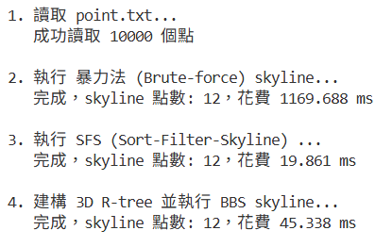
三種查詢演算法比較:
 | 執行速度(跑一萬筆)
暴力法 | 1169.688ms
SFS | 19.861ms
R-tree + BBS | 45.338ms

完整程式碼連結: https://drive.google.com/drive/folders/1H2uZ2cTSk3KVr3R7SxWiQF1SWzgNH_O6?usp=sharing

